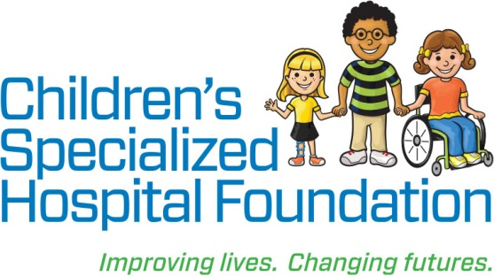MEDIA RELEASE

**Date:** June 5, 2018  
For Immediate Release

**Contact: Rachel Lambert**

[rlambert@childrens-specialized.org](mailto:rlambert@childrens-specialized.org)

P: (908) 301-5567

**Contact: Jessica Arkel**

[jarkel@childrens-specialized.org](mailto:jarkel@childrens-specialized.org)

P: (908) 301-5586

**CHILDREN’S SPECIALIZED HOSPITAL FOUNDATION BOARD WELCOMES ANGELIQUE CARBO**

**MOUNTAINSIDE, NJ:** In support of the largest pediatric rehabilitation health system in the United States, Children’s Specialized Hospital Foundation and its trustees work to ensure financial stability so the Hospital can continue to expertly care for children facing devastating illness and injury. To that end, the Foundation is pleased to announce the appointment of Angelique Carbo to its Board of Trustees.

“The success of the Foundation is considerably impacted by the enthusiasm, leadership, and support of our trustees,” said Philip Salerno, III, president and chief development officer, Children’s Specialized Hospital Foundation. “I am immensely proud of the work we do together and thankful for their dedication to creating better lives for the children and families who benefit from that work.”

**Angelique Carbo** is formerly the Executive Vice President, Chief Human Resources Officer at Selective Insurance Group, Inc. Previously, Ms. Carbo served as the Senior Vice President at ABM Industries. She is a Certified Public Accountant who received her Bachelor’s Degree in Accounting from Georgetown University and her MBA in Human Resources and Organizational Behavior from the Kellogg Graduate School of Management at Northwestern University. In 2017, Ms. Carbo was recognized as one of Black Enterprise’s 300 Most Powerful Executives in Corporate America. She was appointed to the Foundation’s Board of Trustees on February 27, 2018.

**Children’s Specialized Hospital**, a nonprofit organization, is leading the way into a brighter future for children and adolescents facing special health challenges – from chronic illnesses and complex physical disabilities like brain and spinal cord injuries, to developmental and behavioral issues like autism and mental health. **Children’s Specialized Hospital Foundation** supports the programs and services of the hospital and all donations go directly to helping us pioneer new specialized care and serve more children in need. **To help, or for more information: visit** www.childrens-specialized.org; **find us on Facebook** - www.facebook.com/childrensspecialized, **or** **follow us on Twitter** [@ChildrensSpecNJ](https://twitter.com/ChildrensSpecNJ).

###