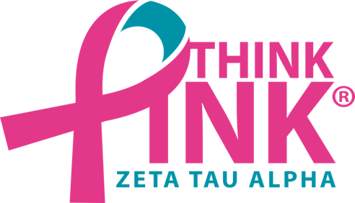MEDIA RELEASE

**Date: October 13, 2019**  
For Immediate Release

**Contact: Rachel Lambert**

[**lambertr@susqu.edu**](mailto:lambertr@susqu.edu)

**908-217-4779**

Zeta Tau Alpha Raises over $1,000 to Support Breast Cancer Education and Awareness

*Carbs for a Cure is a fundraising event held annually in the fall by Zeta Tau Alpha Iota Nu chapter at Susquehanna University to financially benefit the organization’s philanthropy.*

**SELINSGROVE, PA –** The Iota Nu chapter of Zeta Tau Alpha hosted their annual Carbs for a Cure philanthropy event on the evening of Friday, October 4, 2019 and raised over $1,000 in support of the Zeta Tau Alpha Foundation, which benefits causes surrounding Breast Cancer Education and Awareness. Carbs for a Cure is an event where a spaghetti dinner, complete with side dishes and dessert is served with the purchase of a $5 ticket. This year, the meal was donated by the food catering company, Aramark.

The sisters of Zeta Tau Alpha Iota Nu highly anticipate this event every year. Brynn Crawford, Think Pink Chair of the chapter, explained: “Carbs for a Cure went even better than I imagined thanks to the support of attendees, donors, and my sorority sisters. The event brought together many people who believe in fighting this devastating disease and I’m proud that we were able to pass our $1,000 fundraising goal.”

The event, previously simply known as “Spaghetti Dinner”, was held in Susquehanna University’s Degenstein Campus Center and fundraised over $1,000 through ticket sales, general donations, and a variety of raffles for gift baskets from local businesses. The dinner makes a culmination of Zeta Tau Alpha’s Think Pink Week, held annually in the month of October to raise awareness and funds for the fight against breast cancer.

All profits from the philanthropy event will be donated to beneficiaries of the Zeta Tau Alpha Foundation such as Bright Pink, the American Cancer Society, and the National Football League’s Crucial Catch campaign. The Think Chair leads the chapter in fundraising events and is overseen by the chapter’s Director of Philanthropy who plans community service projects both related and un-related to philanthropy. Think Pink has been a registered trademark for Zeta Tau Alpha since 2004 and represents the overall theme of the organization’s philanthropic efforts.

Zeta Tau Alpha Iota Nu currently plans on hosting Carbs for a Cure again next year in early October. Follow [@ztaiotanu](https://www.instagram.com/ztaiotanu/) on Instagram to stay up to date with the chapter’s upcoming events.

**Zeta Tau Alpha’s national philanthropy** is Breast Cancer Education and Awareness. One in eight women in the U.S. will be diagnosed with breast cancer in her lifetime, so this cause is personal. Breast cancer touches many lives. Through local and national partnerships, campus and community initiatives, and the distribution of millions of pink ribbons since 1992, ZTA collegiate and alumnae members are dedicated to our philanthropy. By spreading the message of breast cancer education and awareness, ZTA sisters are determined to diminish this disease.

**Zeta Tau Alpha Women’s Fraternity** was created to make a difference in the lives of our members by developing the potential of each individual. We foster strength of character by emphasizing leadership development, service to others, academic achievement and continued personal growth, with a commitment to friendship and the future. The Iota Nu Chapter at Susquehanna University was chartered in 1985 and has 72 active collegiate members as of April 2019. More than 257,000 women have been initiated into the sisterhood of Zeta Tau Alpha Fraternity since its founding on Oct. 15, 1898, at the Virginia State Female Normal School (now Longwood University) in Farmville, Virginia.

Photo by McKenna Schreck

CAPTION: Attendees of ZTA’s Carbs for a Cure event are all smiles while eating their pasta dinner. The annual event fundraised over $1,000 this year for Breast Cancer Education and Awareness.

###