PRESS RELEASE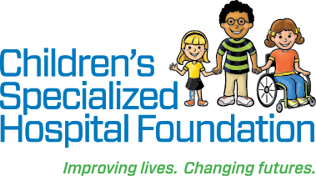

Date: July 3, 2018

For Immediate Release

**Contact: Rachel Lambert**

[rlambert@childrens-specialized.org](mailto:rlambert@childrens-specialized.org)

P: 908-301-5567

**CHILDREN’S SPECIALIZED HOSPITAL FOUNDATION CELEBRATES   
A COOL COMEBACK FOR NATIONAL ICE CREAM MONTH**

*95.5 PLJ FM and Applegate Farm Ice Cream bring back two favorite flavors - Sea Salt Caramel Chocolate Chunk and S’mores Fluff-A-Nutter - to help children facing devastating illness and injuries*

**MOUNTAINSIDE, NJ** – Summer is finally here and we’re screaming for ice cream! July is National Ice Cream month and Children’s Specialized Hospital Foundation is teaming up with 95.5 PLJ-FM and Applegate Farm Ice Cream (616 Grove Street, Montclair, NJ) to bring to life two flavors chosen by listeners of Todd & Jayde in the Morning. Now through Labor Day, a donation of 95 cents will be made to Children’s Specialized Hospital Foundation for every scoop of the two flavors, Sea Salt Caramel Chocolate Chunk and S’mores Fluff-A-Nutter, that are sold.

“We’re excited to partner with Applegate Farm and 95.5 PLJ again this year. We hope everyone will take a break from the summer heat to enjoy these two ice cream flavors and help give back to children and families with special health care needs,” said Philip Salerno, III, president and chief development officer at Children’s Specialized Hospital Foundation.

Additionally, on Wednesday nights now through August 1, Applegate Farm will be hosting Family Fun Nights featuring live music, a magician, movie showings and of course, ice cream. The DJ starts playing music at 6:30 p.m., magician begins at 7:45 p.m. and movies start at 8:30 p.m.

Movie schedule is as follows:

July 11 – Despicable Me 3

July 18 – Coco

July 25 – Jumanji 2

August 1 – Cars 3

Be sure to snap a selfie with your Sea Salt Caramel Chocolate Chunk and S’mores Fluff-A-Nutter ice cream and share it on social media with #PLJFlavors to be entered to win an ice cream party for 25 from Applegate Farm. Sea Salt Caramel Chocolate Chunk is vanilla ice cream, infused with a sea salt caramel ripple and dark chocolate chunks, while S’mores Fluff-A-Nutter is chocolate graham cracker ice cream with peanut butter and marshmallow fluff ripple and dark chocolate chunks.

Since 1848, people have enjoyed fresh dairy products from Applegate Farm. Located fifteen minutes west of New York City, families from Northern New Jersey and New York have travelled miles to enjoy the nostalgia and charm that Applegate Farm offers.

**Children’s Specialized Hospital**, a nonprofit organization, is leading the way into a brighter future for children and adolescents facing special health challenges – from chronic illnesses and complex physical disabilities like brain and spinal cord injuries, to developmental and behavioral issues like autism and mental health. Working with parents and families, our award-winning doctors, researchers and pediatric specialists depend on the generosity of donors to discover new and innovative ways to help more children overcome their health challenges. All donations go directly to helping us pioneer new specialized children’s care and serve more children in need. To help, or find more information: visit www.childrens-specialized.org; find us on [Facebook](http://www.facebook.com/pages/Childrens-Specialized-Hospital/134970126536363?ref=tn_tnmn) - www.facebook.com/childrensspecialized, or follow us on Twitter [@ChildrensSpecNJ](https://www.twitter.com/childrensspecnj).

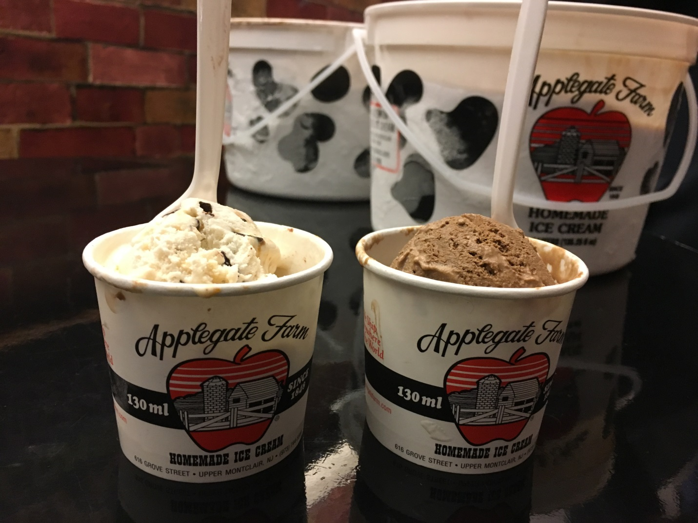

Children’s Specialized Hospital is teaming up with 95.5 PLJ and Applegate Farm Ice Cream in Montclair, NJ to bring two ice cream flavors chosen by listeners of Todd & Jayde In The Morning – Sea Salt Caramel Chocolate Chunk and S’mores Fluff-A-Nutter. Now through Labor Day, a donation of 95 cents will be made to Children’s Specialized Hospital for every scoop of these two flavors sold.

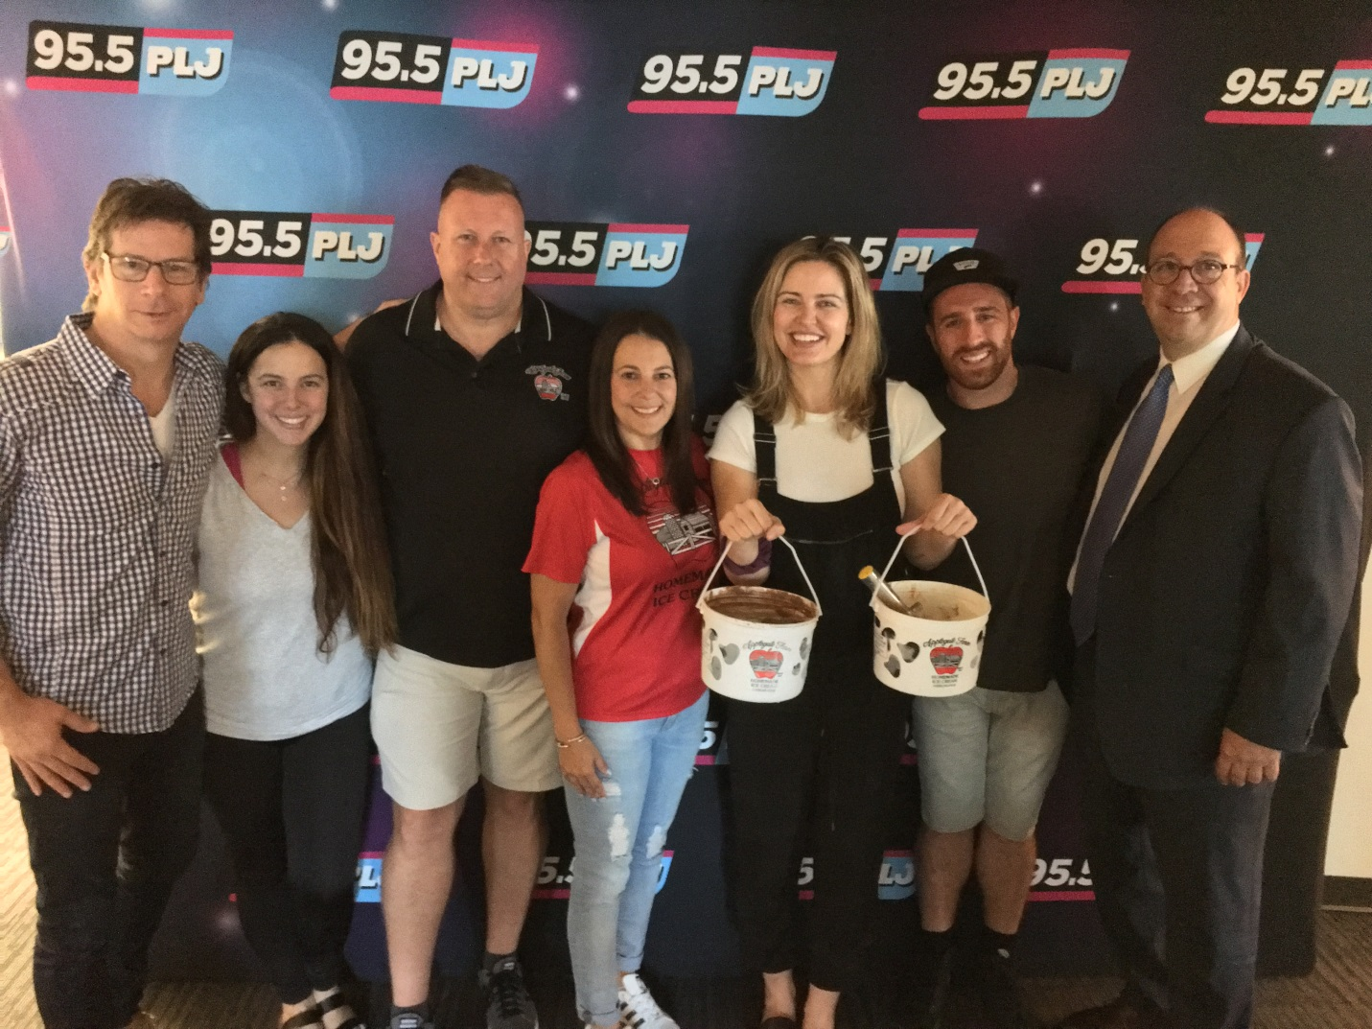

Children’s Specialized Hospital is teaming up with 95.5 PLJ and Applegate Farm Ice Cream in Montclair, NJ to bring two ice cream flavors chosen by listeners of Todd & Jayde In The Morning – Sea Salt Caramel Chocolate Chunk and S’mores Fluff-A-Nutter. Now through Labor Day, a donation of 95 cents will be made to Children’s Specialized Hospital for every scoop of these two flavors sold.

###