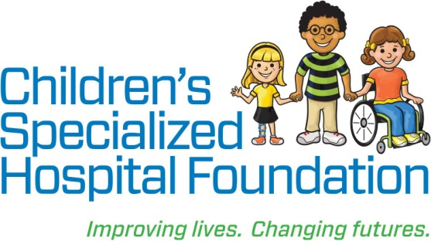MEDIA RELEASE

**Date:** August 13, 2019  
For Immediate Release

**Contact: Rachel Lambert**

rlambert@childrens-specialized.org

P: (908) 301-5567

**Children’s Specialized Hospital Addresses Adverse Childhood Experiences for Children with Autism Spectrum Disorder Thanks to $90,000 Grant from the Healthcare Foundation of New Jersey**

**MOUNTAINSIDE, NJ** – The Healthcare Foundation of New Jersey recently awarded Children’s Specialized Hospital Foundation $90,000 in support of a new program at Children’s Specialized Hospital. The goal of this project, which is a partnership between Children’s Specialized Hospital and Rutgers Robert Wood Johnson Medical School, is to identify and support children with autism spectrum disorder (ASD) in the Newark area who have faced adverse childhood experiences.

“Adverse childhood experiences (ACEs) have been linked to numerable poor health outcomes, including early mortality,” explained Dr. Malia Beckwith, Section Chief of Developmental Behavioral Pediatrics at Children’s Specialized Hospital, as a co-clinical lead of the program. “Children with Autism Spectrum Disorder (ASD) are at increased risk for ACEs; but there has been little work to date to address ACEs in this population. Through the support of the Healthcare Foundation of New Jersey, we will be initiating an exciting new process at our Newark location to screen and identify children with ASD and their families who are experiencing ACEs, and to connect these families to appropriate community supports.  Through this action, we aim to improve overall health for our children with ASD.”

Co-lead of the program, Dr. Manuel Jimenez a Developmental and Behavioral Pediatrician at Children’s Specialized Hospital and an Assistant Professor of Pediatrics and Family Medicine and Community Health at Rutgers Robert Wood Johnson Medical School added: “this proposal will help us implement a team model where physicians, advanced practice nurses, and social workers work together to help begin the healing process for families and address their needs in a holistic manner.”

The program, to begin in October, represents the continuation of a rich relationship between Children’s Specialized Hospital and Healthcare Foundation of New Jersey. In 2013, the Healthcare Foundation of New Jersey provided a half-million dollar gift that helped fund the opening of Children’s Specialized Hospital’s Newark location.

“The generosity of the Healthcare Foundation of New Jersey will allow Children’s Specialized to address a prevalent need in the local community,” said Philip Salerno, III, President and Chief Development Officer at Children’s Specialized Hospital Foundation. “We are so appreciative of their support, which will help children with autism spectrum disorder and their families confront challenges throughout their journey to better overall health.”

“The Healthcare Foundation of New Jersey is proud to support this very important work”, said Marsha Atkind, the Foundation’s Executive Director/CEO. “Our experience has taught us about the impact of ACES on both the physical and mental health of all children. Those with special needs have more and different challenges that this program will now address.”

**Children’s Specialized Hospital**, a nonprofit organization, is leading the way into a brighter future for children and adolescents facing special health challenges – from chronic illnesses ad complex physical disabilities like brain and spinal cord injuries, to developmental and behavioral issues like autism and mental health. **Children’s Specialized Hospital Foundation** supports the programs and services of the hospital and all donations go directly to helping us pioneer new specialized care and serve more children in need. **To help, or for more information: visit** [www.childrens-specialized.org](http://www.childrens-specialized.org)**; find us on Facebook** – [www.facebook.com/chidrensspecialized](http://www.facebook.com/chidrensspecialized), **or follow us on Twitter** [@ChildrensSpecNJ](https://twitter.com/ChildrensSpecNJ).

**About the Healthcare Foundation of New Jersey**

**The mission of the Healthcare Foundation of New Jersey is to improve the health and well-being of vulnerable, underserved populations in greater Newark and the Jewish community of MetroWest NJ, elevate the quality of community healthcare, reduce disparities in access, and promote the infusion of compassion and humanism into our healthcare system.**

###