PRESS RELEASE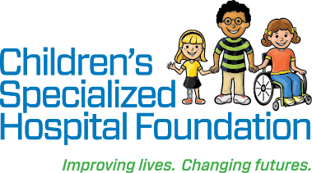

Date: July 5, 2018

For Immediate Release

**Contact: Rachel Lambert**

[rlambert@childrens-specialized.org](mailto:rlambert@childrens-specialized.org)

P: 908-301-5567

**Over $830,000 Raised for Children’s Specialized Hospital Foundation**

**During Miracle Balloon Campaign Thanks to Costco Wholesale**

The annual Miracle Balloon Campaign is the primary fundraising effort made

by Costco Wholesale in partnership with Children’s Miracle Network Hospitals.

**MOUNTAINSIDE, NJ** – For Children’s Miracle Network Hospitals, every month is for making miracles. During the month of May, however, dedicated community partners like Costco Wholesale are especially keen to support the making of miracles at Children’s Specialized Hospital by leading fundraisers such as the Miracle Balloon Campaign.

“We are so grateful for Costco Wholesale’s partnership,” said Nicole Hudson, Director of Fundraising and Operations at Children’s Specialized Hospital Foundation. “They are our single largest corporate partner and their longstanding support has helped to ensure that New Jersey’s children with special health care needs receive the best possible care at Children’s Specialized Hospital.”

During the month-long Miracle Balloon Campaign, members of Costco Wholesale are invited to make a donation to Children’s Miracle Network Hospitals at the time of checkout. CMN balloon icons are granted to donors and are often displayed at the front of the warehouse in appreciation. The annual Miracle Balloon Campaign is the primary fundraising effort made by Costco in its partnership with Children’s Miracle Network Hospitals.

“Here at Costco North Plainfield, the Children's Miracle Network month of May is an exciting time for our employees and our members,” said Mike Freeman, General Manager at Costco Wholesale in North Plainfield.  “We love it!  Bringing the awareness and community spirit of contributing to such a great cause is easy and so rewarding.  Specifically mentioning Children's Specialized Hospital gets an immediate positive reaction!  So many of our members and our team know about and respect the hospital either from personal experience or that of friends or family.  I myself have brought my own child to this great hospital.  The tours that Nicole and the team hold each year really refreshes how important it is for our employees and shows you the great work and unfortunate need and really lights the fire to launch our campaign every May!  We are already getting ideas for next year!!!”

The Miracle Balloon Campaign is a part of the annual *May is For Miracles* fundraising campaign. All proceeds from ***May is for Miracles***campaigns in Northern and Central New Jersey support Children’s Miracle Network Hospitals’ local beneficiary Children’s Specialized Hospital. This year, this campaign is projected to raise over $830,000 by year end. Regional golf tournaments, a corporate match and other creative fundraising activities increase the fundraising total.

**Children’s Specialized Hospital**, a nonprofit organization, is leading the way into a brighter future for children and adolescents facing special health challenges – from chronic illnesses and complex physical disabilities like brain and spinal cord injuries, to developmental and behavioral issues like autism and mental health. Working with parents and families, our award-winning doctors, researchers and pediatric specialists depend on the generosity of donors to discover new and innovative ways to help more children overcome their health challenges. All donations go directly to helping us pioneer new specialized children’s care and serve more children in need. To help, or find more information: visit www.childrens-specialized.org; find us on [Facebook](http://www.facebook.com/pages/Childrens-Specialized-Hospital/134970126536363?ref=tn_tnmn) - www.facebook.com/childrensspecialized, or follow us on Twitter [@ChildrensSpecNJ](https://www.twitter.com/childrensspecnj).

**About Children's Miracle Network Hospitals**

Children’s Miracle Network Hospitals® raises funds and awareness for 170 member hospitals that provide 32 million treatments each year to kids across the U.S. and Canada. Donations stay local to fund critical treatments and healthcare services, pediatric medical equipment and charitable care. Since 1983, Children’s Miracle Network Hospitals has raised more than $5 billion, most of it $1 at a time through the charity's Miracle Balloon icon. Its various fundraising partners and programs support the nonprofit's mission to save and improve the lives of as many children as possible. Find out why children's hospitals need community support, identify your member hospital and learn how you can Put Your Money Where the Miracles Are, at [CMNHospitals.org](http://www.cmnhospitals.org) and [facebook.com/CMNHospitals.](http://www.facebook.com/CMNHospitals)

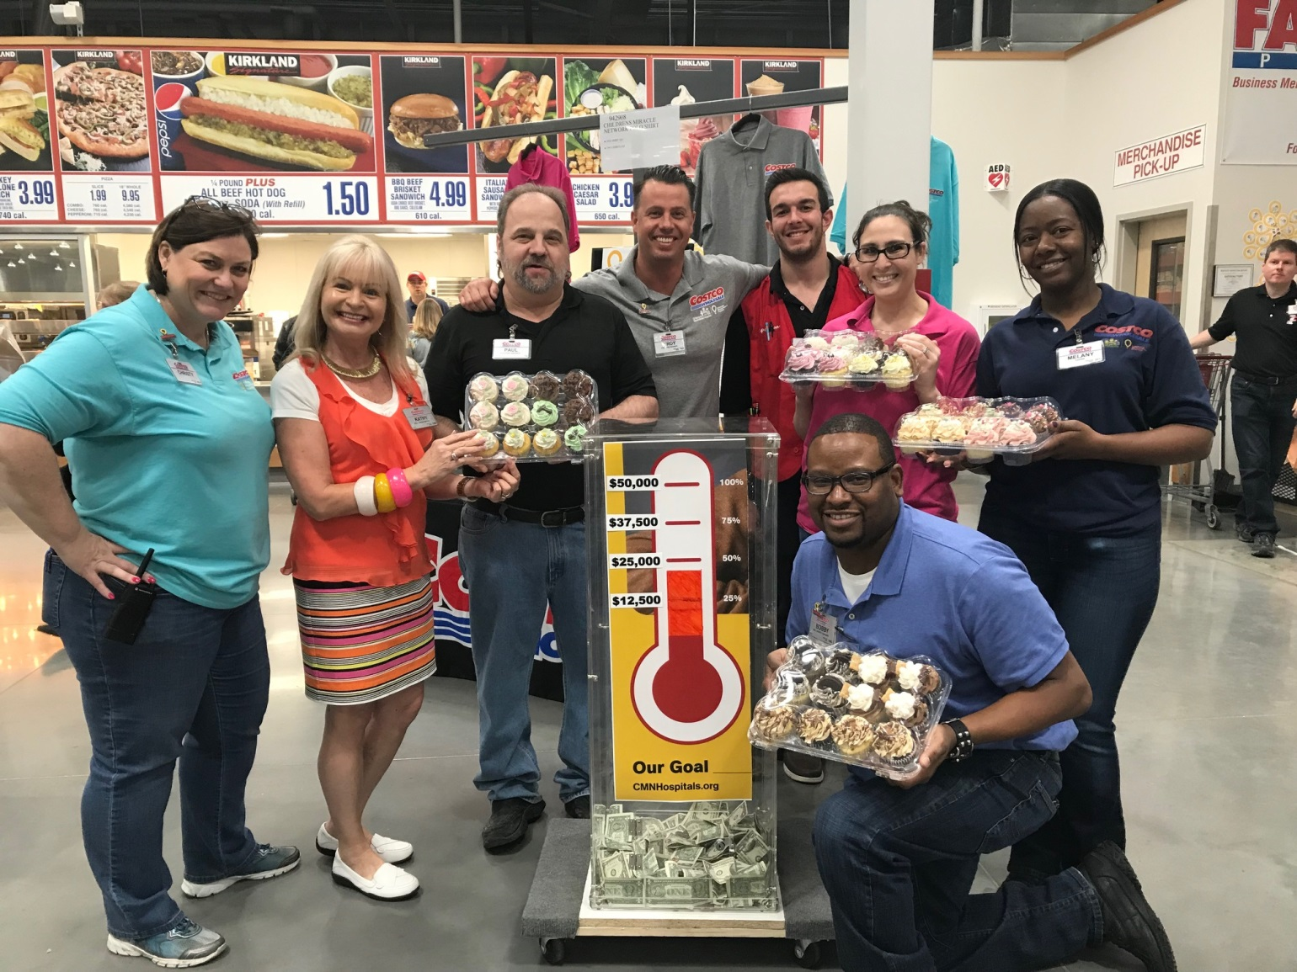

Caption: Costco Wholesale employees and customers across the state of New Jersey teamed up with Children’s Miracle Network Hospitals to participate in the Miracle Balloon Campaign. This year, the campaign raised over $830,000 for children with special healthcare needs at Children’s Specialized Hospital locations throughout the state.

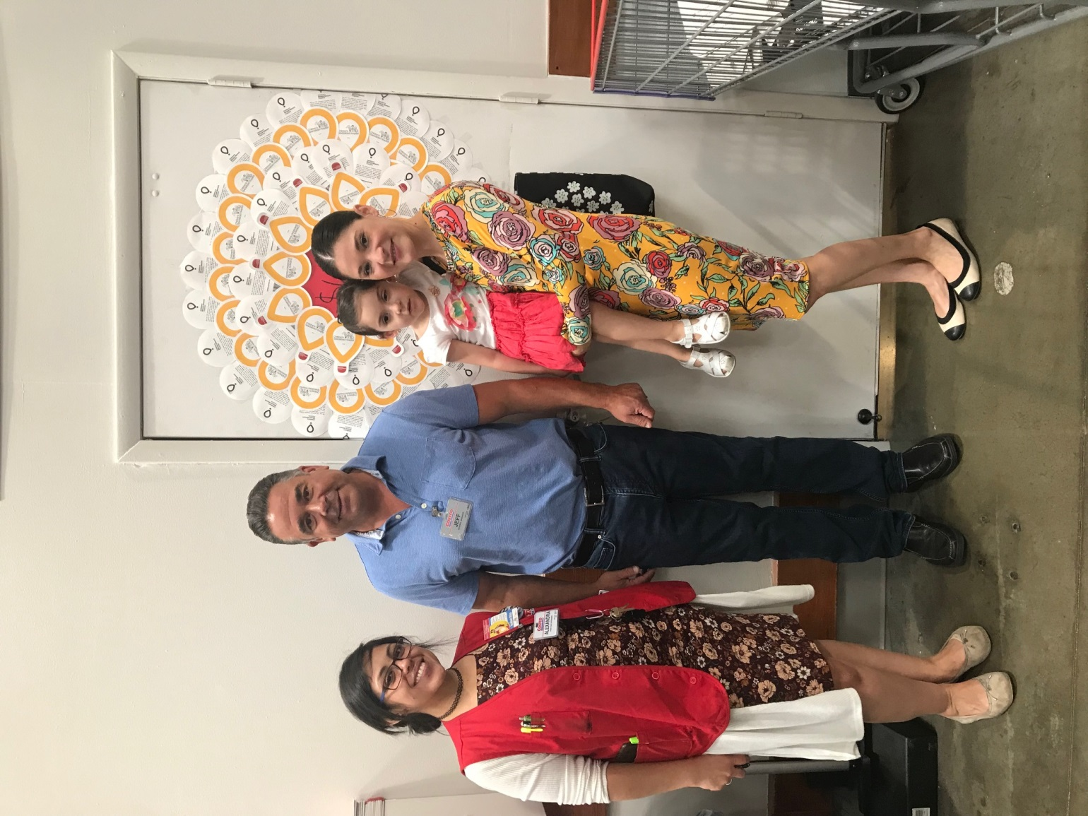

Caption: Costco Wholesale’s Miracle Balloon Campaign helps children like Isabel Rita (pictured), this year’s Children’s Miracle Network Hospitals Champion who is recovering from a spinal cord tumor. The campaign raised over $830,000 this year for children with special healthcare needs at Children’s Specialized Hospital.

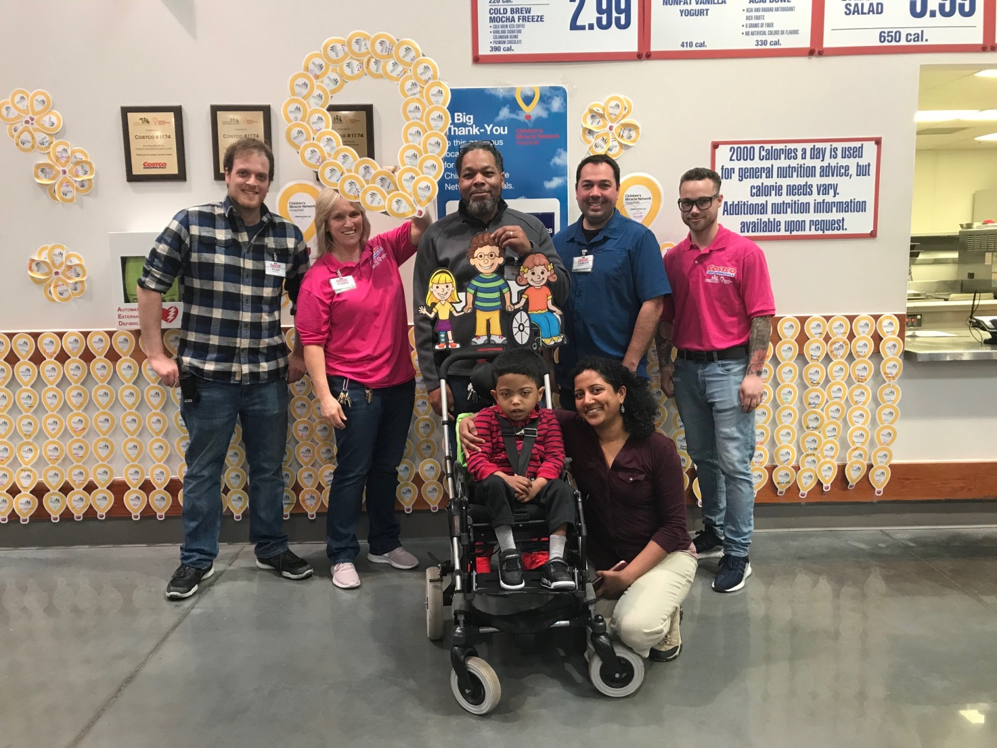

Caption: Costco Wholesale employees and customers across the state of New Jersey continue to participate eagerly in the Miracle Balloon Campaign. This year, the campaign raised over $830,000 for children with special healthcare needs at Children’s Specialized Hospital.

###