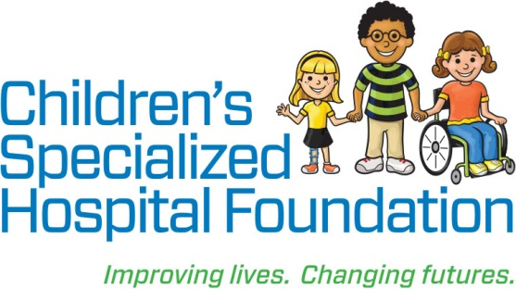MEDIA RELEASE

**Date:** July 11, 2018  
For Immediate Release

**Contact: Rachel Lambert**

rlambert@childrens-specialized.org

P: (908) 301-5567

**Children’s Specialized Hospital patients Learn essential healthy**

**cooking skills to help manage chronic illness**

*Wakefern Food Corp.’s $25,000 donation heats things up for the Let’s Cook for Wellness Program*

**MOUNTAINSIDE, NJ –** Wakefern Food Corp., the merchandising and distribution arm for ShopRite supermarkets, recently granted Children’s Specialized Hospital Foundation $25,000 in support of *Let’s Cook for Wellness,* a collaborative educational program between Children’s Specialized Hospital and Elijah’s Promise in New Brunswick, NJ. This unique program provides culinary training and nutrition education for patients in the hospital’s Chronic Illness Management Program helping them to manage their chronic illness better and maximize quality of life.

For many young adults suffering from a chronic illness, like diabetes, requires drastic lifestyle changes in order to regain control of their lives. Approximately two-thirds of children and adolescents who have chronic illnesses are non-adherent to their prescribed regimens putting them at greater risk for complications and additional health problems. Diabetes, specifically, affects over 200,000 children and adolescents in the United States and that number is on the rise.

Launched in 2006, Children’s Specialized Hospital’s Chronic Illness Management program is a comprehensive four to six-week inpatient program for children and adolescents, who struggle to manage their chronic condition. The program provides tools and resources geared specifically towards teens and young adults. From weekly outings to local restaurants, exercise, shopping, counseling to help deal with the emotional aspects of managing their diseases and cooking experiences through the *Let’s Cook for Wellness* program, patients are better equipped to manage their chronic illness.

Ayana Hamilton, Patient Care Navigator, Chronic Illness Management Programat Children’s Specialized Hospital, has witnessed first-hand the impact of the *Let’s Cook for Wellness* program. “Patients learn skills essential to healthy management of their illnesses in real-life settings,” said Hamilton. “Parents are also encouraged to take part in the program, and often are ecstatic to see the immediate impact in their child’s life.”

Karen Meleta, Vice President of Corporate Communications, Wakefern Food Corp., stated, "Wakefern is proud to support Children's Specialized Hospital and their extraordinary commitment to children who face special health challenges. The *Let's Cook for Wellness* program compliments the efforts of our ShopRite Dietitians, who work every day to help families learn about healthy foods and make more nutritional choices."

“Working with community partners such as Wakefern Food Corp. and ShopRite allows us to have a direct impact in helping children with chronic illness learn about proper nutrition and develop the healthy lifestyle they need to live the most productive life possible,” said Philip Salerno, III, president and chief development officer at Children’s Specialized Hospital Foundation. “The *Let’s Cook For Wellness* program is critical to their success.”

**Children’s Specialized Hospital**, a nonprofit organization, is leading the way into a brighter future for children and adolescents facing special health challenges – from chronic illnesses ad complex physical disabilities like brain and spinal cord injuries, to developmental and behavioral issues like autism and mental health. **Children’s Specialized Hospital Foundation** supports the programs and services of the hospital and all donations go directly to helping us pioneer new specialized care and serve more children in need. **To help, or for more information: visit** [www.childrens-specialized.org](http://www.childrens-specialized.org)**; find us on Facebook** – [www.facebook.com/chidrensspecialized](http://www.facebook.com/chidrensspecialized), **or follow us on Twitter** [@ChildrensSpecNJ](https://twitter.com/ChildrensSpecNJ).

**About ShopRite**ShopRite is the registered trademark of Wakefern Food Corp., a retailer-owned cooperative based in Keasbey, NJ, and the largest supermarket cooperative in the United States. With more than 270 ShopRite supermarkets located throughout New Jersey, New York, Pennsylvania, Connecticut, Delaware and Maryland, ShopRite serves more than six million customers each week. Through its ShopRite Partners In Caring program, ShopRite is dedicated to fighting hunger in the communities it serves. Since the program began in 1999, ShopRite Partners In Caring has donated $43 million to food banks that support more than 2,100 worthy charities. As a title sponsor of the ShopRite LPGA Classic Presented by Acer, ShopRite has donated $30 million to local organizations, hospitals and community groups. For more information, please visit [www.shoprite.com](http://www.shoprite.com).

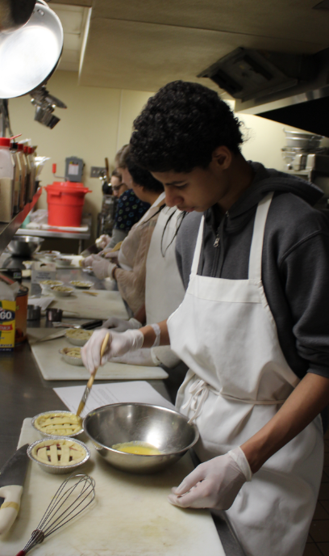

Jay Evangelista, a patient of Children’s Specialized Hospital’s Chronic Illness Management Program, learns cooking skills at Elijah’s Promise. This opportunity was funded by Wakefern Food Corp./ShopRite’s $25,000 grant to the *Let’s Cook for Wellness* program partnership between Children’s Specialized Hospital’s Chronic Illness Management Program and Elijah’s Promise.

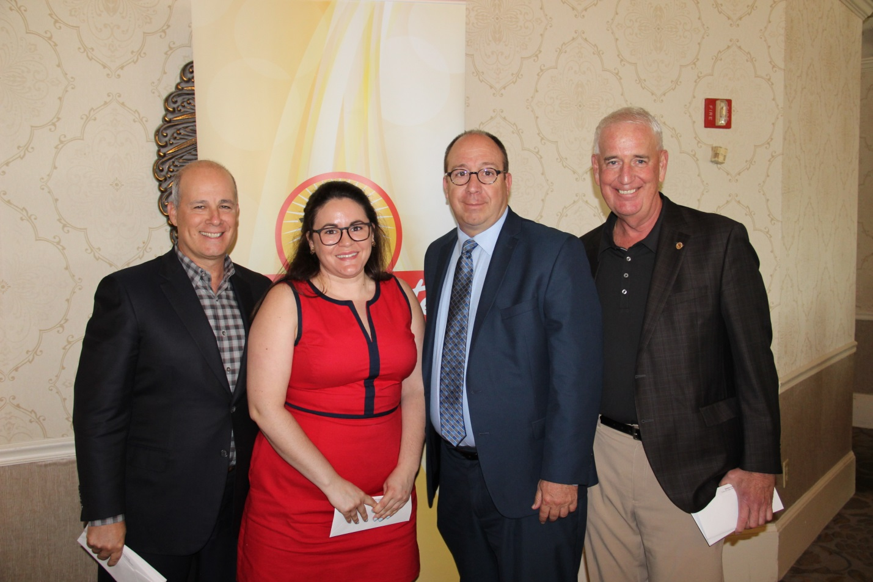

President Joe Sheridan (far right) and Executive Vice President Chris Lane (far left) of Wakefern Food Corp. grant a check for $25,000 to the *Let’s Cook for Wellness* program at Children’s Specialized Hospital. The check was presented at the 2018 LPGA Community Luncheon in Galloway, NJ.

###