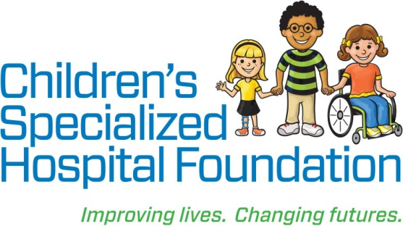MEDIA RELEASE

**Date:** June 5, 2018  
For Immediate Release

**Contact: Rachel Lambert**

rlambert@childrens-specialized.org

P: (908) 301-5567

**Contact: Jessica Arkel**

[jarkel@childrens-specialized.org](mailto:jarkel@childrens-specialized.org)

P: (908) 301-5586

**CHILDREN’S SPECIALIZED HOSPITAL FOUNDATION WELCOMES JOHN R. BLASI TO BOARD OF TRUSTEES**

**MOUNTAINSIDE, NJ:** In support of the largest pediatric rehabilitation health system in the United States, Children’s Specialized Hospital Foundation and its trustees work to ensure financial stability so the Hospital can continue to expertly care for children facing devastating illness and injury. To that end, the Foundation is pleased to announce the appointment of John R. Blasi to its Board of Trustees.

“The success of the Foundation is considerably impacted by the enthusiasm, leadership, and support of our trustees,” said Philip Salerno, III, president and chief development officer, Children’s Specialized Hospital Foundation. “I am immensely proud of the work we do together and thankful for their dedication to creating better lives for the children and families who benefit from that work.”

**John R. Blasi** is an Attorney-at-Law at Lindabury, McCormick, Estabrook & Cooper, P.C. in Westfield, NJ. As a former member of the Board of Trustees for the Robert Wood Johnson Healthcare Cooperation and RWJ Health Network, and a current member of the John F. Byrne Foundation, The Humming Board Foundation, Inc., the Elizabethtown Foundation, as well as Children’s Specialized Hospital, Blasi brings extensive experience to the Foundation’s Board. Furthermore, Blasi is highly involved with the community as the former President of many local organizations including the Rotary Club in Westfield, NJ, Crestview Tennis and Swim Club in New Providence, NJ, the Summit, NJ Police Athletic League, and the American Red Cross, New Jersey Chapter. Blasi, Children’s Specialized Hospital’s appointee, was elected to the Foundation Board on February 27, 2018.

**Children’s Specialized Hospital**, a nonprofit organization, is leading the way into a brighter future for children and adolescents facing special health challenges – from chronic illnesses and complex physical disabilities like brain and spinal cord injuries, to developmental and behavioral issues like autism and mental health. **Children’s Specialized Hospital Foundation** supports the programs and services of the hospital and all donations go directly to helping us pioneer new specialized care and serve more children in need. **To help, or for more information: visit** www.childrens-specialized.org; **find us on Facebook** - www.facebook.com/childrensspecialized, **or** **follow us on Twitter** [@ChildrensSpecNJ](https://twitter.com/ChildrensSpecNJ).



